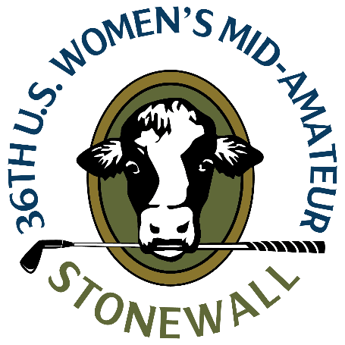
U.S. Women’s Mid-Amateur
Saturday, Sept. 9, 2023
Stonewall, North Course
Elverson, Pa.
Katie Miller
Oakmont, Pa.
1-under 70 (first round, stroke play)

Q. One of only a couple rounds under par today. How are you feeling after that round?
Katie Miller: “I hit it great all throughout the practice rounds. I felt pretty good this morning, but timing was a little off the first few holes and I managed it really well, and just kept my head totally in it. Then just got a little more committed once I made the turn.”
“With the greens, they’re crazy, but if you can get your approach shot in the right quadrant of the green, instead of having to navigate all the undulations, you’ll have some good looks. And I actually had a ton of good looks, and then was finally able to capitalize on two of them there coming down the stretch. I was just glad to stay patient with that too because it was a smidge frustrating when I was hitting good shots.”
“All in all, just mentally hung in there. Just pushed through.”
Q. How about Stonewall. Have you played here before being from PA?
Katie Miller: “My first time here. From Pittsburgh area, you hear of it. When I told people we were playing here, a lot of people said, “oh, it’s cool. It’s a cool spot.” It absolutely is. It’s awesome. You do still feel at home with the cow logo and some of the pastures. I definitely like the Pennsylvania feel.”
Q. Coming off a win last month at the WGAWP Amateur, how confident are you in the way you’re playing?
Katie Miller: “I do feel pretty good about my game right now. I was really pleased with the practice rounds. It’s just funny. Mom life now. There’s a thousand things going on, and I don’t really practice much in the winter. So at the beginning of the season, you dust them off and get going and sort of have to play through the pain a little bit to get yourself back to where you’re seeing good lines and making good choices and knowing the right numbers and distances.”
“It took me a minute to get it together and then I feel like I had a pretty solid July and beginning of August, so I felt prepared because I at least had a few competitions under my belt.”

