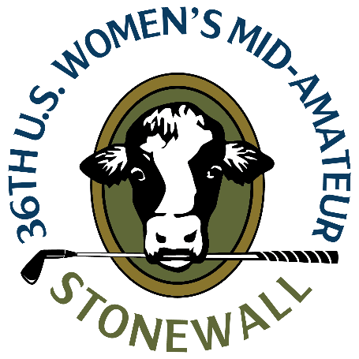
U.S. Women’s Mid-Amateur
Sunday, Sept. 10, 2023
Stonewall, North Course
Elverson, Pa.
Jessica Spicer
Bahama, N.C.
1-under 70 (second round, stroke play)
Championship – 69-70--139 (3-under)

Q. Another round under par. How was it out there?
Jessica Spicer: “It was an interesting start with the two-hour delay. I didn’t know how much we were going to get in, so I was very thankful that we had good weather for the whole round. My sister bought a $140 rain jacket in the pro shop before we went out, so I told her that’s probably why it didn’t rain again. So I appreciate that.”
“My swing felt a little bit off today, but I did a good job grinding it out and staying patience. I made some good saves and made a couple birdies and just stayed in it mentally.”
Q. Was the course playing much differently today than yesterday?
Jessica Spicer: “The ball wasn’t rolling out much at all. It was soft yesterday I thought, but it was even softer today. So a couple of the par 5’s that were reachable yesterday were definitely playing longer today. Coming into the greens, it was pretty soft. It was a little bit different, but you just adjust and go with it.”
Q. How do you feel about your game heading into match play?
Jessica Spicer: “I feel pretty good. There’s a couple thing I’d like to tighten up a bit. It’s a long week. It’s a marathon, not a sprint. Everyone’s going to hit a few bad shots here and there so I’m just going to keep trying to do what I’m doing and see how it goes.”
Q. What the birdie on 4 like?
Jessica Spicer: “No. 4 was probably the longest putt I’ve made so far. It was about 25 feet, and it was a multi-breaker, a little bit downhill. I just hit it perfectly. As soon as I hit it I knew it had a chance and it just crept in last roll. So that was a good one. I had just missed a short birdie putt on the hole before, so it felt good to make that and get the momentum back.”
Q. Were you following the leaderboard much out there? Did you know you were close to possibly being co-medalist?
Jessica Spicer: “I didn’t look at the scoreboard at all and I knew that [Courtney] shot a 64 yesterday, so I honestly didn’t figure that I was anywhere near [the lead]. I just crept in my putt on the last hole for par and then they told me that I was tied for first, so I was like, “okay, I’m glad that went in.”
“That would obviously be a great honor if it holds up, and if not, it’ll be a good seed for match play.”

