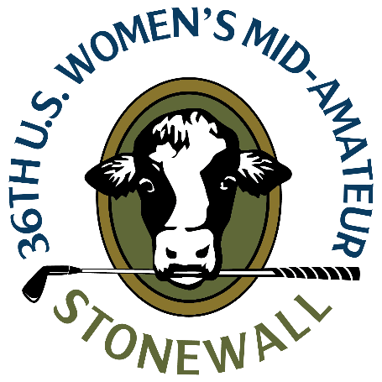
U.S. Women’s Mid-Amateur
Sunday, Sept. 10, 2023
Stonewall, North Course
Elverson, Pa.
Courtney Dow
Frisco, Texas
4-over 75 (second round, stroke play)
Championship – 64-75--139 (3-under)

Q. I know it wasn’t the finish you were looking for. What happened there on 17 and 18?
Cortney Dow: “All day I struggled a little. Nothing was too good. Nothing was too bad. I went from having a lot of looks at birdie to just tap in pars most of the round today.”
“I had a few bad swings that really cost me, a couple misread putts, and nothing really saved me or got me any shots back once I made a mistake.”
Q. The job isn’t finished, but how does it feel to be in position to earn medalist honors heading into match play?
Courtney Dow: “It’s fun. It’s encouraging that the strategy and the way I’ve approached the course was the right one and that I managed my way around well and can be competitive in any match that I’ll draw.”
“I think my approach will be pretty similar in terms of trying to get to the right tiers of greens and leaving myself with the right putts. I didn’t do that on the last couple holes coming in and leaked out three-putts that cost me a few shots down the stretch.”
Q. How did the course play today compared to yesterday?
Courtney Dow: “It played a little different [today]. It added a club or club and a half coming into the greens in a lot of places, but also made some of those tucked pins on elevated back tiers a little bit tougher to get at. They were softer and I was seeing my ball spin back a little more than yesterday, so had to be cautious of what angle the ball was coming in at and playing with some of the softness.”

