U.S. Junior Amateur
Wednesday, July 26, 2023
Daniel Island Club, Ralston Creek Course
Charleston, S.C.
Rowan Sullivan, Charleston, S.C.
def. Jon Ed Steed, 19 holes (Round of 64)

Q. What a finish. Tell us about that match.
[ROWAN SULLIVAN]: I was down all day. I was never up until the 19th hole when I won it. Jon is a hell of a player. He played really well today. I think we both played some really solid golf.
We both traded blows in the beginning, then he built a lead when I made some mistakes, but I never gave up. I knew that my game was there. To win, you have to play the whole match well, so I kept playing.
I made a late birdie in the middle of the back nine to his par and then got it down to two or one. Then on 18, I hit my tee shot and then the horn blew, so we sat on our second shots into 18 for about an hour and a half. Then wracked my brain over what I can do to win this hole.
I stepped out after the delay, and despite what most people told me I should do, I laid up and hit a wedge shot to 20 feet and ended up making the putt which was really, really cool. Then got it done on 1 with another birdie.

Q. What did you do during the break?
[ROWAN SULLIVAN]: Grabbed some lunch and just chilled with my friends, talked with my roommate. Tried to laugh a little bit and feel some good things before I went out and had to possibly face my last couple shots of junior golf.

Q. You were down 3 holes multiple times during the match, I think on hole 7 and then again on hole 13. What was going through your head and what did you and your caddie talk about?
[ROWAN SULLIVAN]: I consider myself a good match play player, and my caddie is an experienced golfer in his own right. So we knew that we just needed to trust ourselves. I felt like I never got scared; never got down on myself. I’ve been working on learning to focus on the things around me when I hit bad shots and not focus on the bad shots because if you just focus on those, you’re not going to win.
We didn’t necessarily talk about the match much. We just talked about what I needed to do to succeed.
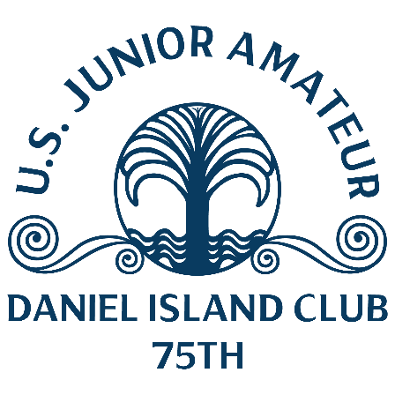

Q. We saw a lot of people cheering you on here at the end. Who are some of the folks following you today?
[ROWAN SULLIVAN]: People from my home club (Country Club of Charleston), people that are friends of a friend, people that are Daniel Island Club members. All people that are just nice enough to come watch me. I really appreciate it and I want them to know that that really makes a different for me. Especially on the last hole when they were clapping for me. That was awesome.

Q. What got you more fired up, the putt on 18 or the tight approach on the last hole?
[ROWAN SULLIVAN]: The putt on 18. I sat on that for an hour and a half, and knew I had to do it, so that was definitely the bigger shot.

Notes:
Birdie on par 5 18th: Hit tee shot in the fairway, then the horn blew. Waited almost two hours. Laid up with his second shot to 105 yards, then hit 56-degree wedge to 20 feet. Made birdie putt.
Birdie on par 4 1st (extra hole): 320+ yard drive down the middle of the fairway. 100-yard approach to 3 feet. Made birdie putt.

