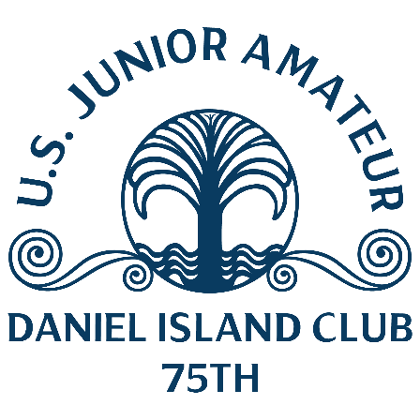
U.S. Junior Amateur
Tuesday, July 25, 2023
Daniel Island Club, Ralston Creek Course
Charleston, S.C.
Matt Moloney,
Daniel Island, S.C.
1-over 73 (second round, stroke play)
Championship – 71-73—144 (1 over)

Q. Was it nervous time at the end?
Matt Moloney: “It was an atrocious finish. I told my caddie I lost the only thing that you need to do well on Ralston (Creek) is hit your driver. I was spraying my driver on the last five holes. It’s not something you can really do. But we made it. That’s all that matters, just making it to the next day.”
Q. What is it like to make match play on your home course?
Matt Moloney: “Anything can happen. I had a great front nine, I was 3 under. I love Ralston (Creek). I typically always play Ralston very well, I just didn’t hit my driver very well on the last couple (of holes). It’s a good course for me, I am happy to play anyone out there. I feel confident, I am excited to go tomorrow.”
Q. What are the keys to playing Ralston Creek in match play?
Matt Moloney: “Just driver, knowing when to be aggressive and when to lay back. Match play is a whole different game. I hit a couple of 3-woods off the tee where I am not going to hit 3-wood tomorrow. The whole key to Ralston is being in the fairway.”
Q. How much have you played match play?
Matt Moloney: “Not that much in the past year. The last time I did was in the Junior Presidents Cup in a tournament, so it’s been awhile. In the Wyndham Cup last year I was like a nobody coming in and I ended up playing the No. 1-ranked guy in singles and I beat him. [It was] unexpected, but the script could be flipped, I could be the better guy and someone could beat me. Don’t take anything for granted and take one shot at a time.”

Q. What kind of support did you have today?
Matt Moloney: “It was great. I had the more friends, the same people out there, members popping in and out. It was fun. It’s definitely an advantage.”
Notes – Moloney is a member at Daniel Island Club. He started his second round at Ralston Creek Course’s 11th hole. He was 3-under par through 10 holes but finished double-bogey, bogey and bogey over his final three holes.

