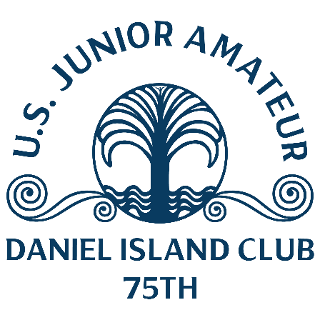
U.S. Junior Amateur
Monday, July 24, 2023
Daniel Island Club, Beresford Creek Course
Charleston, S.C.
Carson Kim,
Yorba Linda, Calif.
5-under 66 (first round, stroke play)

Q. What was your hot stretch like during the round?
Carson Kim: “I was struggling with the driver in the beginning, trying to find the fairway. I started to find it and started hitting it straight. I really started giving myself a lot of opportunities at birdie. I started putting it close and making some putts.”
Q. What about your eagle from 40 yards at the par-5 10th?
Carson Kim: “I was a little short left and I thought it was going to be a pretty tough spot. I got it up and luckily it hit the pin and went right in.”
Q. Did his birdie on the seventh hole get him going?
Carson Kim: “Just had it barely in the rough and I had a pretty good number to the pin. I had a nice full 60 (degree wedge) and it landed and went to about 2 feet.”
Q. You followed with a birdie on the par-5 eighth, how did that happen?
Carson Kim: “I actually pushed the drive pretty far right but got a pretty good break up in the trees. I had a good shot to the green and put it greenside. A little chip and putt and it was a birdie right there.”
Q. How would you rank this round in your short career?
Carson Kim: “This is probably one of the best rounds I have played, especially in a tournament. This course is certainly not easy. The rough is really punishing and the greens are firm. I really felt like my game was solid today. I played great.”
Q. What is your philosophy going into the next round of stroke play?
Carson Kim: “For me I just have to stay focused and keep my foot on the pedal, so to speak. Don’t really get complacent. Honestly just try to put up as good a round as I can tomorrow.”
Q. Can you explain the process of changing your commitment to Georgia Tech?
Carson Kim: “I actually signed with USC but then there was a coaching change made about a month and a half ago. I was uncertain whether I wanted to go because I had committed to the coaches who were there previously. It was a tough decision but I decided to request my release. I really liked what they had going on at Georgia Tech. I thought it was a really good fit for me.

