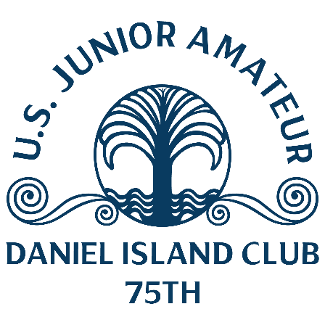
U.S. Junior Amateur
Tuesday, July 25, 2023
Daniel Island Club, Ralston Creek Course
Charleston, S.C.
Bryan Kim,
Brookeville, Md.
def., Jackson Byrd, 6 and 5, Round of 64

Q. Can you talk about playing well in match play after making it for the first time?
Bryan Kim: “I played in the Wyndham Cup about a week ago, it’s all match play. That got me ready for this week and I felt like I got in good rhythm. Just keeping the pedal down when I am up or even when I am down.
“I had not made match play at a USGA event so for this to be my first one in my last Junior means a lot.”
Q. How did you get a big lead early?
Bryan Kim: “I was playing really solid, I only missed one or two greens today. Obviously Jackson (Byrd) didn’t have his A-game but it was nice to see that I am hitting quality shots, just playing my own game and let the rest take care of itself.”
Q. What did you learn about match play as you played in the Wyndham Cup?
Bryan Kim: “I never saw myself as a great match-play player. At Wyndham Cup I learned to just keep the pedal down, don’t get complacent especially when you are up. It’s all about momentum. You have to keep the hammer down and win as many holes as you can.”
Notes – Kim went 3 up early. He had a 20-foot eagle putt on the par-5 sixth that he lagged to 3 feet to win the hole. He later went 4 up on No. 11 by hitting a 250-yard, 3-iron to the fringe and two-putted for a birdie. He increased his lead to 5 up on the par-3 12th. He hit a 5-iron to within 5 feet after making a “7” on the same hole in the first round of stroke play.

