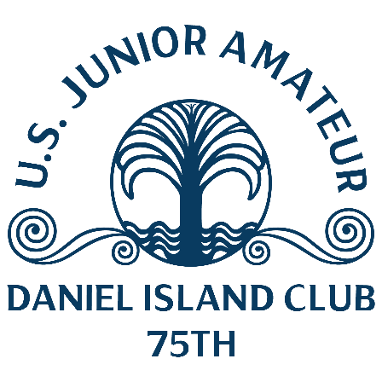
U.S. Junior Amateur
Tuesday, July 25, 2023
Daniel Island Club, Beresford Creek Course
Charleston, S.C.
Billy Davis,
Spring Valley, Calif.
2-under 69 (second round, stroke play)
Championship – 69-69—138 (5 under)

Q. How do you explain having just one bogey in two days?
Billy Davis: “I was hitting it pretty good both days. My one bogey was a 3-putt from 20 feet, so I have been swinging pretty good and my lag putting is pretty good this week.”
Q. Why have you been so accurate in hitting fairways and greens?
Billy Davis: “I have been just hitting it pretty good. I have been taking it one play at a time, it has helped me. I have just been hitting it better, more greens and more fairways.”
Q. Is making match play a big accomplishment for you?
Billy Davis: “The goal was to play good enough, maybe get a good seed and then just see how we do from there because anything can happen in match play.”

Q. Have you played much match play?
Billy Davis: “I played in the Wyndham Cup last week. We played like a Ryder Cup format and I like it. It’s a good format, it’s different.
“You have to treat every hole like its own little match. Literally anything can happen. You can be 3 down at one point and the next thing you know you are even. Small runs like that can happen.”
Q. Where would you rank these two days in your young career?
Billy Davis: “This is my first USGA event and my last year trying to qualify [for the Junior Amateur]. I really wanted to qualify and I am pretty happy that I am here and played well.”
Notes – Davis had six birdies and one bogey in his two stroke-play rounds. He was bogey-free with two birdies in the second. He hit a 97-yard approach to set up a birdie on No. 11, his second hole, and added a 6-foot birdie putt on No. 2. His twin sister, Anna, played in the last two U.S. Women’s Opens (2022, 2023).

