2019 U.S. SENIOR OPEN CHAMPION MEDIA TOUR
Monday, July 1st, 2019 (Time Zones Indicated)
8:20 – 8:45 a.m. EDT | Golf Channel Morning Drive FACETIME LIVE REMOTE  Dial the MDFaceTime@golfchannel.com email at 8:20 a.m. EDT to check in audio and video. If having any issues dial the hotline 1-855-898-4653.  * Full instructions on next page
9:00 – 9:20 a.m. EDT | Golf Digest Podcast – Alex Myers
9:30 – 9:50 a.m. EDT | GOLF – Jonathan Wall  Dial-in: (817) 688-3179
5:00 – 5:20 p.m. EDT | Sirius XM PGA Tour Radio – Katrek and Maginnes  Dial-in: (866) 831-4008  Producer: Jon Albanese

Tuesday, July 2nd, 2019 (Time Zones Indicated)
8:35 – 9:00 a.m. EDT | Sirius XM PGA Tour Radio – Fairways of Life  Dial-in: 866-831-4008  Producer: Dom Scarano

Contact Info:
USGA/Buffalo.Agency: Ben Cramer (c: 904-347-5131)
USGA: Jeff Altstadter (c: 973-908-9991)

FaceTime Guide for Morning Drive
- Use your newest apple device as it will have the best camera. Using an iPad or Mac is best.
- Place it on its side leaning against something on a table in a well-lit room.
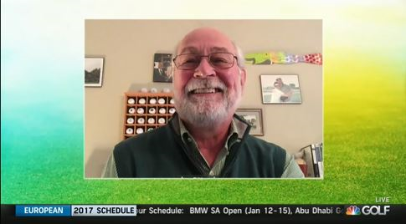
Make sure the Portrait Orientation Lock button is off if your screen remains upright.
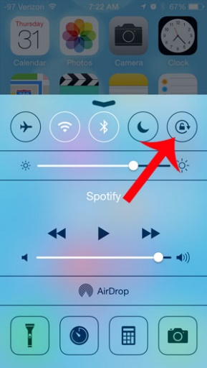
- If you are outside, do not have the sun directly behind you.
- If you are using a laptop, make sure that your image is full screen (landscape mode not portrait).
- If you can, wear earbuds with a microphone that can plug into your device. This will help you hear the show better and cut down on interference.
- Please dial the MDFaceTime@golfchannel.com email 10 minutes before your scheduled interview to check in audio and video. If you are having any issues please dial the hotline 1-855-898-4653. If all else fails, the emergency call in number is 407-802-2414.

