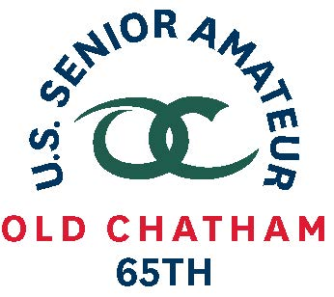
65th U.S. SENIOR AMATEUR CHAMPIONSHIP – Player Quotes

Aug. 24-29, 2019, Old Chatham Golf Club, Durham, N.C.

Paul Simson, Raleigh, N.C.

First-Round Stroke Play (5-over 77)

Worst stroke-play round in 13 starts in U.S. Senior Amateur. His stroke average coming into the championship was 71.25 (24 rounds)

“I’ve kind of been fighting a little neck issue and it’s been tough to swing at it. I feel a little bit better than we’re in at 77, and maybe if I can get it a little looser tomorrow, we can get us a decent round and get into match play.” (On his round)

“It felt a little bit better. I started hitting a few more good shots. So maybe I’m getting used to dealing with it. But I missed a couple of short putts and I had three or four wedge shots that were either skulled or something stupid. If I hadn’t done that, I would have had a decent round. I’m not out of it. But I’m going to make it a little more exciting than I usually do going into match play.” (When asked if his body started feeling better towards end of round when he made consecutive birdies on 16 and 17 and a nice par save on 18)

“That’s an honor. I think they did that for [North Carolina native] Scott Harvey down at Pinehurst also [for the 2019 U.S. Amateur]. I think that’s a really nice gesture. It’s something you always will remember, which is kind of cool. I think the USGA some great things with feature pairings. You’ve got some nice pairings out there, which it makes it more fun for us [Senior Amateur] guys and for some of the gallery people.” (On having the honor of hitting the first tee shot of the championship)

“This was an anomaly. It’s just one of those things. I’ve looked forward to this [week] for a long time. It’s unfortunate that I have a little bit of a crick in the neck. It was better today. Ibuprofen, message and maybe a hot tub and a hot shower.” (On his worst round in Senior Am history and playing through the pain)

