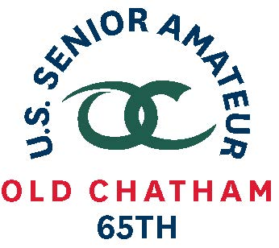
65th U.S. SENIOR AMATEUR CHAMPIONSHIP – Player Quotes

Aug. 24-29, 2019, Old Chatham Golf Club, Durham, N.C.

Michael McCoy, Norwalk, Iowa

First-Round Stroke Play (even-under 72)

(on his success on par 5s)
“I kept the ball in the fairway on the drive and the second shot because if you hit it in the rough it is a whole different ballgame. That was the key.”

(on his play)
“It was a good score. If you drive it the fairway, with the big greens, you can play. But if you hit in the rough it is a lot of work out there. It is hard to get a club through with it wet and gnarly.”

(on competing in his second U.S. Senior Amateur)
“In general, you have more confidence. You are playing against your peers on a more reasonable golf course than some of the ones I have playing on.”

Notes (started on No. 1)
11 – 5-foot birdie putt, 54-degree wedge
14 – 6-foot birdie putt, 54-degree wedge
17 – bogey after hitting his tee shot in water, hit approach behind the hole and rolled back to one inch

