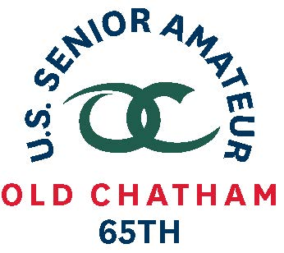
65th U.S. SENIOR AMATEUR CHAMPIONSHIP – Player Quotes

Aug. 24-29, 2019, Old Chatham Golf Club, Durham, N.C.

Marvin (Vinny) Giles, Richmond, Va.

First-Round Stroke Play (4-over 76)

“I’m at least at 260 and I didn’t start counting until I was 70. Most of that isn’t in competition.” (On shooting age)

“I actually played OK. I missed two little 2-foot putts for being careless and then three-putt there [on No. 18]. But I don’t make any birdies. I made 14 pars and four bogeys, and three of the bogeys were bad bogeys. One of them I just hit a horrible shot and deserved a bogey.” (On his round)
“It’s the only goal I have anymore. I’m spotting [most of the field] 20 years and probably 30 or 40 yards. Quite honestly, that was my goal.” (When asked about making match play)

“Almost none. This will be my last [U.S. Senior Amateur]. I haven’t really played with a pencil in my hand since April at the Coleman. That’s the last real tournament I played. I realize that my [competitive] days are over. I still enjoy playing. But I don’t have any delusions of grandeur.” (Expectations for the week)

