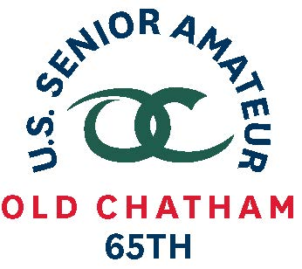
65th U.S. SENIOR AMATEUR CHAMPIONSHIP – Player Quotes

Aug. 24-29, 2019, Old Chatham Golf Club, Durham, N.C.

Dean Channell, Cary, N.C.

First-Round Stroke Play (4-under 68)

(on his play)
“I really hit it good. I think I hit 15 greens so that makes a difference. I putted well. I hit a lot of shots that were close so I gave myself a bunch of chances.”

(having played the course approx. 25 times)
“Without question it helped me. I am familiar with the shots. It played a lot faster when it first opened so it has changed over the years. But it is nice to look at a green and semi-know what the contour is. You don’t have to stress about it.”

(on being first alternate)
“I was lucky to get it as an alternate. I have been an alternate several times and so I was not counting on it. As it turns out, the place I qualified was the top-rated site but there was no way for me to know that when I went. I played well in the qualifier and there were a bunch of good players there.”

(on conditions)
“You rather not play in these conditions and I am not a mudder. It worked out.”

Notes (started on No. 10)
12 – pitched in for birdie from 20 yards left of the flagstick on the par 3 … carried the ball 45 feet onto the green and it rolled another 18 feet …
14 – landed approach on the right fringe and chipped to within one inch for tap-in birdie on par 5
2 – 8-iron to within 6 feet right of the hole to set up birdie on par 3
3 – wedge to within 3 feet above the hole to set up birdie putt
6 – raining hard, 9-iron, 128 yards … made sweeping 15-foot birdie putt
8 – 25-foot birdie putt

