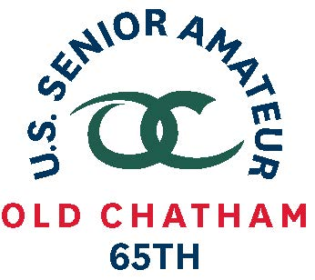
65th U.S. SENIOR AMATEUR CHAMPIONSHIP – Player Quotes

Aug. 24-29, 2019, Old Chatham Golf Club, Durham, N.C.

Brian Cain, Montpelier, Vt.

First-Round Stroke Play (1-under 71)

(on his eagle at No. 10)
“It was a pretty good way to start a USGA national event. I got up to the green and said, “Where is it?” I thought maybe it went in that back swale but it was just too good a shot.”

(on his play)
“I think when you are in competition like this it is the pars that you are proud of. That ones that you are grinding for and one that you get up and down. I had three or four of those that kept a good round going. Couldn’t be anything more than thrilled to be in the red.”

(on tomorrow)
“There are so many good players here. Many players can do the same thing that I did today.”

(on playing in his first USGA championship)
“I don’t play a lot of recreational golf. I still am addicted to competitive golf and standing over a ball and knowing that you have to execute. My experience is mostly in New England but I have a lot of it. Once I got inside the ropes it felt like, “I want to hit this shot”.”

Notes (started on No. 10)
10 – eagle – 9-iron, 135 yards
17 – birdie – 5-iron, 172 yards to within one inch, landed next to flagstick, climbed to the top hill and came back down
4 – key par – hit a good 4-iron approach that jumped into the front bunker, up and down
6 – missed a 5-foot birdie putt to go 5-under on the round
7 – double-bogey – incorrect read on his bogey putt after a poor approach
He and his wife Lilli are celebrating their 28th wedding anniversary today (Aug. 24)

